ApexaIQ Day 6 (Assignment 2)

* **About Apexa iQ:**

Apexa iQ is a private company specializing in IT asset management solutions. Their platform offers comprehensive visibility into an organization's technology ecosystem, enabling enhanced security, efficiency, and compliance. By providing insights into hardware, software, firmware, and access controls, Apexa iQ helps organizations manage their IT assets effectively.

* Key Features of Apexa iQ:

1. **Asset Discovery:** Identifies and catalogs all IT assets, including servers, IoT devices, and software applications.
2. **Compliance Management:** Ensures adherence to industry regulations and standards by monitoring asset configurations and usage.
3. **Risk Assessment:** Evaluates potential vulnerabilities within the IT infrastructure to prioritize remediation efforts.
4. **Lifecycle Management:** Tracks the status and health of assets throughout their lifecycle, from procurement to decommissioning.

* Industries Served by Apexa iQ:

**Financial Services and Banking:** Assists in managing sensitive financial data and ensuring regulatory compliance.

**Healthcare:** Supports the secure management of medical devices and patient information.

**Insurance:** Helps in managing policyholder data and maintaining system integrity.

* Apexa iQ IT Risk Score:

**Apexa iQ** is a SaaS based platform that delivers your IT Risk Score, asset Compliance, Obsolescence, Maintenance and Vulnerability in a single dashboard.  
  
In this dashboard, they give you a quantified and an actionable summary of your internal IT. This score, your Apexa iQ, is inspired by human IQ and ranges between 60 (poor) to 160 (genius).  
  
Your Apexa iQ is like a credit rating for your entire IT estate, including every device on your network. It computes all your risks and security gaps into a single score, based on the most vital obsolescence and compliance factors. The higher the score, the stronger and more secure your IT environment.

THE SCORE IS CALCULATED BASED ON 3 DIFFERENT THINGS

1. IT Environment
2. Asset Hygiene - Obsolescence, Maintenance, Vulnerabilities
3. IT Gaps

The **Apexa iQ** dashboard gives you complete visibility into your IT environment. You can see how many laptops, servers, network routers, cloud devices, and IoT devices that your company has. Their dashboard allows you to also go more in depth into these devices seeing device types, vendors, and other endpoint risks by vendor.  
  
One of the greatest things about this product is their real-time reporting. With that, you are able to see if any of your hardware, software, or operating systems are obsolete, nearing or have reached end of life, which devices are nearing expired warranties and maintenance, and which devices are vulnerable. Needing to know which devices you should patch first? Their dashboard gives you a list of vulnerabilities from critical down to low to show you what you should be patching first.  
  
The last data point that they use to score your internal IT is based on your IT security gaps. The **Apexa iQ** dashboard gives you visibility into which devices are compliant and which ones aren’t.  
  
Their dashboard allows you to set a compliant benchmark rule, using rules. And from there, you can receive emails on any device that is no longer compliant so that you can take action and make your **Apexa iQ** higher.

Apexa iQ can have following data:

1. Hardware

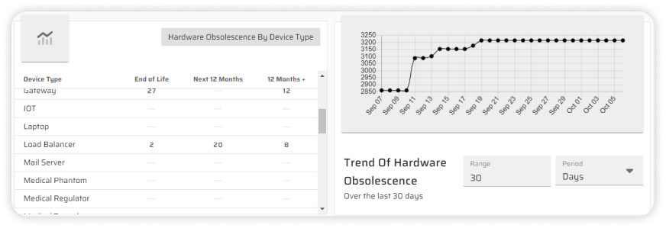

1. Software

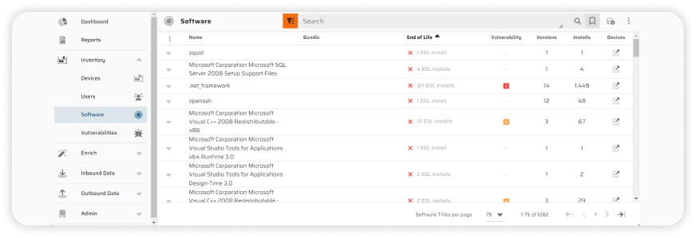

1. Firmware

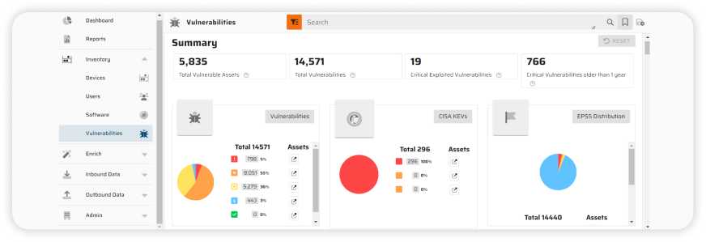

1. Access

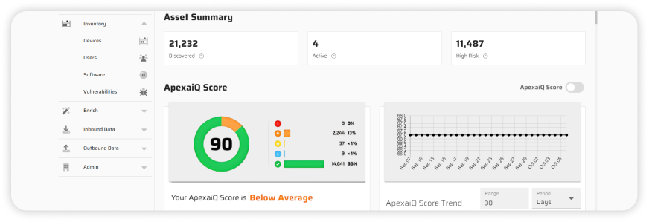

* Apexa iQ Competitors:

